Color-aware debugging

1. Learning objectives
By learning to use STM32F103RCT6 and the color recognition module, the color recognition module recognizes the red, green and blue colors, and the serial port outputs the recognized RGB data.

2. Prepare before class
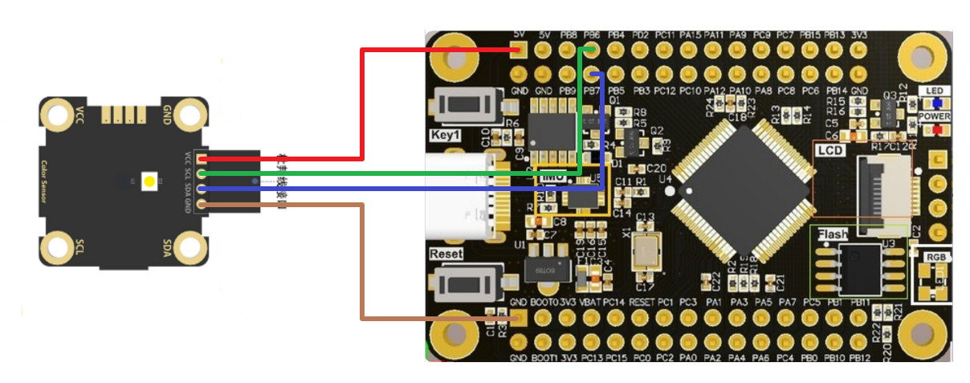
Color recognition module | STM32F103RCT6
VCC | 5V
SCL | PB6
SDA | PB7
GND | GND

3.Programmatic
keil programming: first of all, we will use st-link as a downloader, we need to press the four connectors of st-link to connect the corresponding pin above STM32F103RCT6, then open keil, click the magic wand to select debug and select the corresponding downloader such as st-link, and then click settings to appear This interface can be downloaded normally.
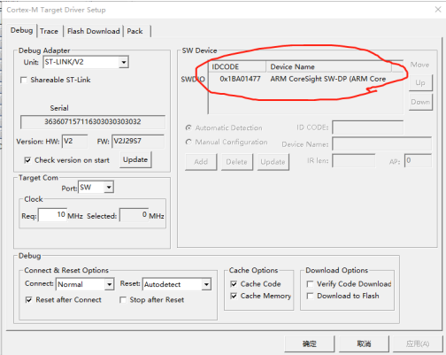

4.Main code
Serial port initialization:
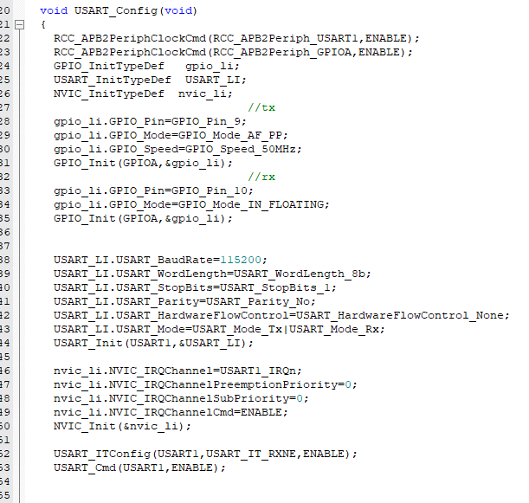
TCS34725 color recognition initialization:
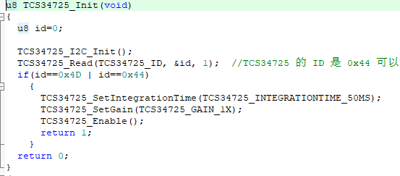
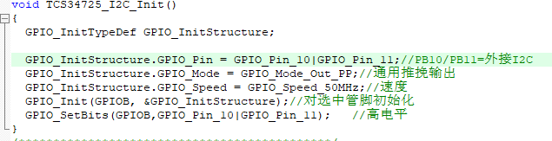
TIM3 timer initialization:
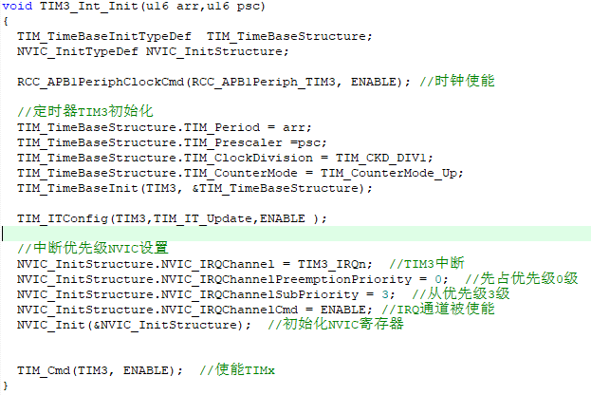
The initialization mainly uses serial port pin initialization and color recognition module chip TCS34725IC initialization and timer initialization.

Main function
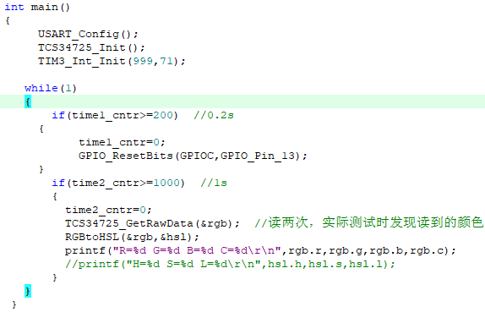
The main function calls the color channel to obtain the data function and the RGB to HSL function, and finally prints out through the serial port.

5. Experimental phenomenon
